CNN Facial Recognition Literature Background Paper

John Robinson

CSC-498-01

This particular research is an exploration of artificial intelligence and deep neural networks in relation to image recognition. The foundation and basis for starting this research is the wide number of applications as well as the potential of this field. Before diving into understanding the facial/image recognition element there must be understanding of the building blocks that support it.

The baseline to take into account is Artificial Neural Networks. “ANNs are processing devices (algorithms or actual hardware) that are loosely modeled after the neuronal structure of the mammalian cerebral cortex but on much smaller scales”(shipyard). Neural networks are usually organized into layers which are made up of interconnected nodes which contain an activation function. Patterns are presented by an input layer which communicates to hidden layers which process the input. This is connected to an output layer. ANN’s are trained by feeding large quantities of data. Training at a basic level is providing input to ANN and then telling it what the input should be. To break it down a neural network is a number of artificial neurons called units separated by a series of layers. The units are separated into different specific types. The first being input units, input units are for receiving some sort of information that the neural network will process. There are also output units which are what the neural network does with the information it processes. What's in between are the previously mentioned layers which are also units but they are hidden units. Another concept to consider is that most neural networks are fully connected which means every hidden unit and output unit is connected to every unit on either side of it.(Woodford, 2020)(Kailash, 2017)

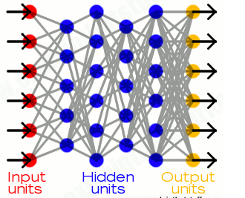

Figure 1 (Woodford, 2020)

The connections between units are related to what's called weight, which is a number that is assigned randomly and used to correct the output. The larger the weight the more influence the units have on each other. This can either be negative or positive, whether it is one or the other determines how it influences the units. The process of actual learning is normally done by feeding an input which is processed by the hidden units and then arrives at the output layer, this is all a process called forward propagation. The way it is processed is “Each unit receives inputs from the units to its left, and the inputs are multiplied by the weights of the connections they travel along. Every unit adds up all the inputs it receives in this way and (in the simplest type of network) if the sum is more than a certain threshold value, the unit "fires" and triggers the units it's connected to (those on its right).”(Chris Woodford). This idea is supported by Figure 3 on the next page.

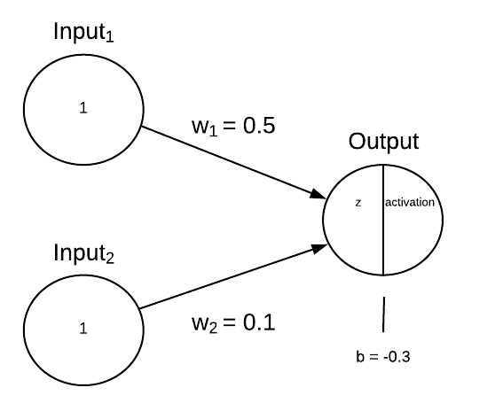

Figure 2 Tóth, B. (2018, August 13)

The simplest way to explain the math behind neural networks is to explain how the Perceptrons neural network are calculated. Before going further its best to cover what a Perception is. “Perceptron is a single layer neural network and a multi-layer perceptron is called Neural Networks.“Sharma, S. (2019, October 11)To start the input layer will input a number of values. Based on the number of inputs, there is the same number of weights for each respective input. The weight is then multiplied by the input values and then the sum is added with the a bias value which is usually always one as it is mostly there to ensure neuron activation if the inputs are all zero. The bias is usually randomly assigned much like the weight.(Woodford, 2020)(Kailash, 2017), Sharma, S. (2019, October 11)

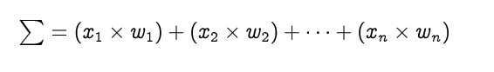



Figure 3 (Saravanan, 2020)

In some cases activation functions are performed to introduce non linearity to the neural network. “Activation functions — are used to introduce non-linearity into the output of the neurons, without which the neural network will just be a linear function.”(Dasaradh K. Saravanan) In this case for the Perceptrons the sigmoid activation function is used, this can be seen in figure 4 at the top left side. Others can be used but this is the one being used in the example. The result of the previous formula for z is entered into the activation function and the result is the predicted value and end result for forward propagation when it comes to a Perceptron neural network.

(Woodford, 2020)(Kailash, 2017), Sharma, S. (2019, October 11)

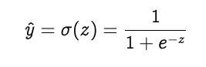

Figure 4 (Saravanan, 2020)

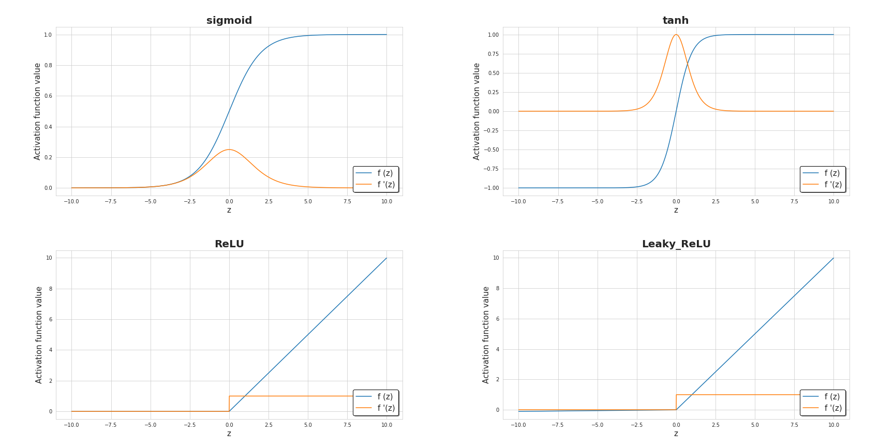

Figure 5 (Skalski, 2018)

Doing Forward Propagation has a predicted value, calculating the error is done by comparing the predicted output with the actual output. Accounting for errors in that method is called backward propagation. Using the differences found to change the weights between the units which results in the neural networks output to become closer to the expected output, thus in a way learning. The next major part is the part that leads to error prediction. Calculating the loss function can be done in a number of ways. The loss function is used to change the gradients in a neural network. The gradients are how the weights are updated. The several major loss functions are mean squared error, binary cross entropy, Categorical Cross Entropy, and Sparse Categorical Cross Entropy. The most commonly used of these is the mean squared error, this is simply the mean squared difference between predicted vs expected values which can be observed in figure 5.



Figure 6 (Deeplizard)

The total sum simply being the squared difference of every node summed. To calculate the gradient we must find the derivative of the loss in respect to the weights. So the formula would be the derivative of the loss over the derivative of the weight. This is for a single node so the weight would be for a specific node. Using the chain rule the derivation will look like this.

(Saravanan, 2020) (Skalski, 2018) (Deeplizard), K., H. M. (2019, November 03), Ahirwar, K. (2017, November)

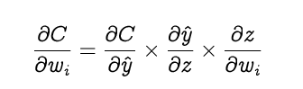

Figure 7 (Saravanan, 2020)

The derivative of the loss function over the weight of the node i equals the derivative of the loss function in respect to the activation function times the derivative of the activation function in respect to the input for node i times the derivative of the input to node i in respect to the weight. The sum of the three derivations is how backpropagation calculates the gradients of the loss in respect to the weights of the network. Next the process of gradient descent occurs which “is an iterative optimization algorithm for finding the minimum of a function; in our case we want to minimize the error function. To find a local minimum of a function using gradient descent, one takes steps proportional to the negative of the gradient of the function at the current point”K., H. M. (2019, November 03), this is also illustrated in figure 8. So the old weight is subtracted from the arbitrary learning rate a which is determined beforehand much like the bias multiplied times the result of the chain rule calculation with the loss function. The result is the new weight. This is done until the local mininia is found.

(Saravanan, 2020) (Skalski, 2018) (Deeplizard), K., H. M. (2019, November 03), Ahirwar, K. (2017, November)

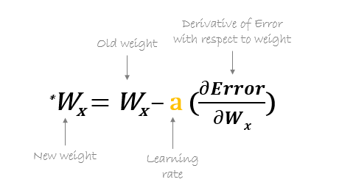

Figure 8

There are many types of neural networks, the major one to be covered is the Convolutional Neural Network. The main reason this was chosen above others was due to its popularity for image recognition. Going in depth with Convolutional Neural Networks starts with “When a computer sees an image (takes an image as input), it will see an array of pixel values. Depending on the resolution and size of the image, it will see a 32 x 32 x 3 array of numbers.”(Adit Deshpande). The three at the end refers to the three channels red, green, blue. For grayscale images there is only one channel. So for example a jpg is used for an input its size is 480x480 pixels. The array will be 480x480x3. Each array position will have a value between 0 and 255. So for color images there are 3 array’s filled with values of 0-255 while greyscale will have just the one array of 0-255. The general idea is then based on combinations of the array filled with numbers that will provide a probability that it is a certain object. ”ConvNets derive their name from the “convolution” operator. The primary purpose of Convolution in the case of a ConvNet is to extract features from the input image. Convolution preserves the spatial relationship between pixels by learning image features using small squares of input data”(ujjwalkarn). The actual Convolutional layer is an analysis of the previously mentioned array’s. What occurs is a much smaller array called a filter, neuron or kernel which slides across the larger array. The section being checked against the other array is called the receptive field. As the filter slides the array values in the receptive field are being multiplied by the elements in the filter. The multiplications are then summed and put into a new result array called the feature map.(Adit Deshpande)(Ujjwalkarn, 2017)

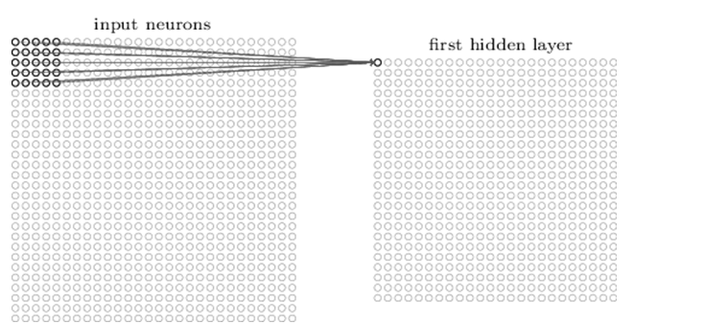

Figure 9 (Adit Deshpande)

The filter will move one position right until it hits the far right side then start again on the left one position lower than where it last checked. The process of sliding and multiplication is called Convolved Feature. The size of the aforementioned convolved feature is based on 3 parameters. The depth which determines the number of filters in use. Stride is the number of pixels which are slid over in the input matrix. Lastly is zero padding which is when you pad the input matrix with zeros around the border so the filter can be applied to bordering elements. It is also used to control the size of the feature map. Wide vs narrow convolution.is just having vs not having zero padding. CNN’s have other features. Determining the dimensions after one pass through a convolutional layer can be determined by a simple formula. (AISHWARYA SINGH, 2020)

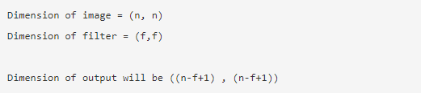

Figure 10 (AISHWARYA SINGH, 2020)

Another small feature which may be used is the rectified linear units activation function which simply is just when a negative number is swapped with a zero. “This helps the CNN stay mathematically healthy by keeping learned values from getting stuck near 0 or blowing up toward infinity”(e2eML school). The last feature to cover is pooling which essentially is taking large images and shrinking them down while keeping the important information. The process is just a small window that goes through the input array and makes a new array with the largest value in that window. It moves just like the convolutional layer. Based on the previously mentioned mechanics a classic CNN would go through input, convolution, ReLU, convolution,ReLU,pooling,convolution, ReLU,pooling, to being fully connected. (AISHWARYA SINGH, 2020)

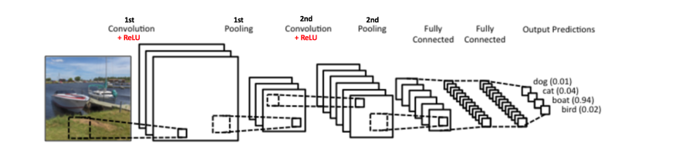

Figure 11 (Ujjwalkarn, 2017)

The fully connected layer is the last few layers of the network. “This layer basically takes an input volume (whatever the output is of the conv or ReLU or pool layer preceding it) and outputs an N dimensional vector where N is the number of classes that the program has to choose from. For example, if you wanted a digit classification program, N would be 10 since there are 10 digits. Each number in this N dimensional vector represents the probability of a certain class”(Adit Deshpande). In the context of a cNN the fully connected layer takes what the previous convolution layer output which would be an array of a certain size that is converted into a one dimensional array. The new one dimensional array is what is sent to the fully connected layer where linear and non linear transformations occur. Linear transformation is done by the formula Z = W^T.X + b, X being the input, W is the weight and b being the bias. The weight was discussed in the previous neural net section; it changed during the backpropagation when the neural net is trying to find a specific value. The bias is a constant that is mostly there to guarantee that even when all inputs from layers are zero there is still neuron activation. So as shown below the input array, weight arra

+y and bias are all condensed into an equation for the linear transformation which is the last step in a cNN’s forward propagation process. In some cases activation functions are performed during the process, the ReLU is one of these functions but there are others depending on what is trying to be achieved. (AISHWARYA SINGH, 2020)(Ujjwalkarn, 2017)

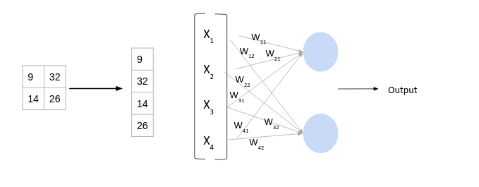

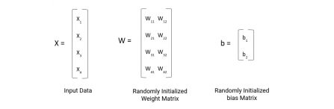

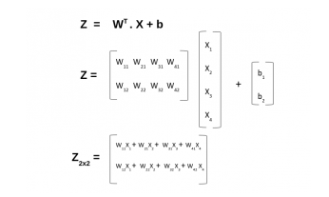

Figure 12 Aishwarya, S. (2020, May 08)

Application for Neural Networks for facial recognition has vast options at the current moment. CNN’s seem to be the best overall approach but it has its downsides. One big one being “they lack a very important property of incorporating any prior information [ 6 ]. When applied to expression analysis, it seems insufficient to well describe expressional images as variations such as identities add redundant noises to these features.” Xie, S., & Hu, H. (2017, January 24). This can be made up for with the concept of TI-pooling. Ti pooling is the process of making a CNN transformation invariant. At a basic level based on transformations such as rotations, scale changes, shifts or illumination changes the output will not depend on whether of not the input was transformed. This is essentially done by transforming the original image to a set of transformations. Every transformation is a parallel instance of a partial siamese network. Each instance only having convolutional and subsampling layers.

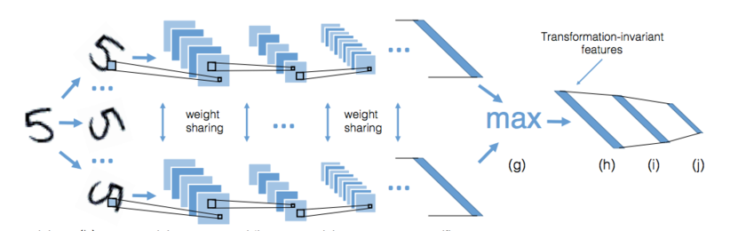

Figure 13 (Dlaptev)

The instances are passed until reaching the fully connected layer similar to normal CNN. The other important to solving the aforementioned issue is that most CNN’s use one channel. A solution discussed in Siyue Xie’s article was the use of siamese networks which uses multiple channels to enhance the power of discriminative features. These channels also use the above-mentioned Ti-pooling. To summarize, “images from the same transformation set are set as the inputs of identical parallel channels. Then, each image passes through the convolutional module and yields a concatenate feature vector. Weight sharing is implemented among all the channels. TI-pooling is implemented across all these channels” Xie, S., & Hu, H. (2017, January 24)(Dlaptev)Laptev, D., Savinov, N., Buhmann, J., & Pollefeys, M. (2016, September 22)

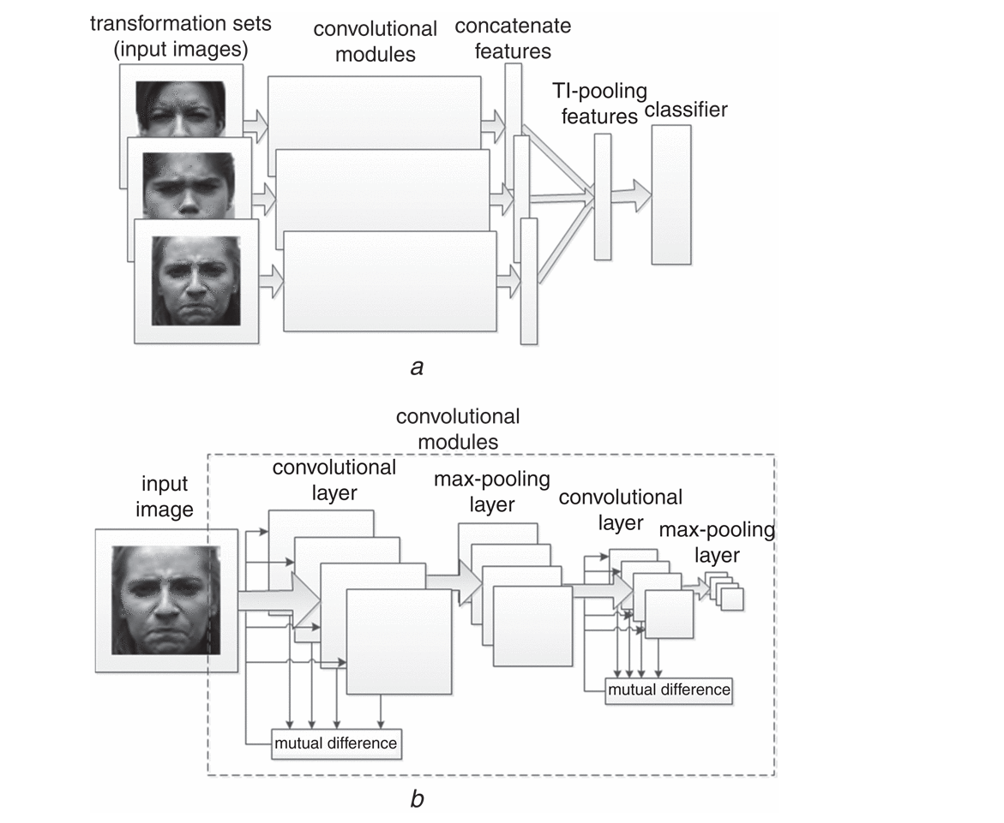

Figure 14 Xie, S., & Hu, H. (2017, January 24)

Another concept is the geometric feature based networks. This is another type of CNN that in relation to facial recognition “captures the movements of the landmarks of emotion. The feature of the partial elements obtained by detecting the movement of the landmark is added to the overall features so that more robust features can be extracted”(Ji-Hae Kim, 2019). The main part of gCNN is the process of capturing dynamic changes in facial expressions and extracting landmarks in the face. An example would be the eyebrows, nose ,eyes etc… Xie, S., & Hu, H. (2017, January 24)

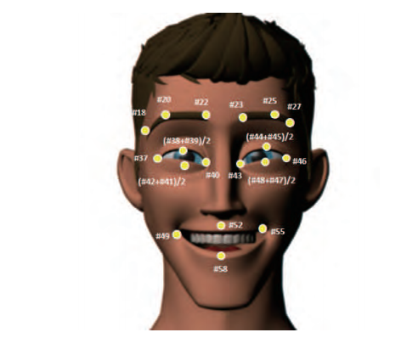

Figure 15 Kim, J. (2017)

gCNN are similar to standard CNN’s with the exception that they are involved with surface data. gCNN architecture is made up of input data layer, mesh convolutional layers with data reshaping, batch normalization layers, ReLU layers, mesh pooling layers and lastly fully connected layer. This goes deeper than an experiment will likely go, but it is a possible avenue. Kim, J. (2017) Xie, S., & Hu, H. (2017, January 24)

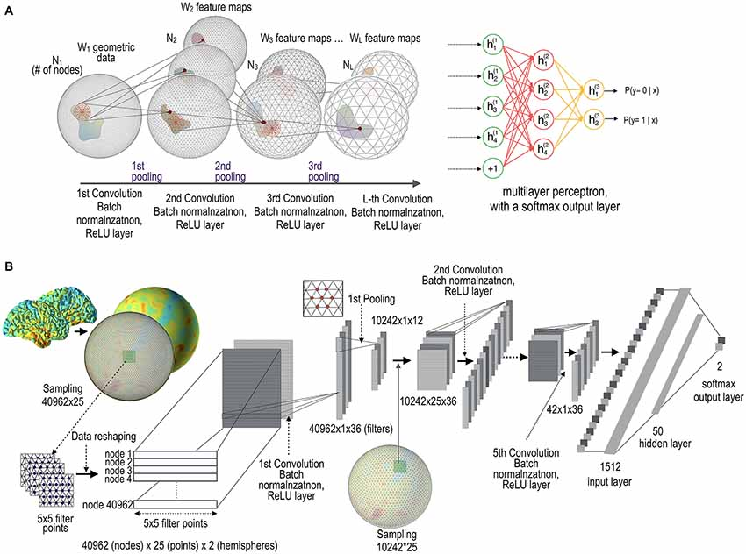

Figure 16 Seong, S. (2018, June 12)

Coming down to actually training a convolutional neural network is commonly done within a python framework. Usually something such as Google colab or jupyter notebook. A large dataset is also required for the learning process, the larger the better. Operating a cNN does not require the large dataset but the neural network will have a larger accuracy when it comes to facial recognition the larger the dataset. Seong, S. (2018, June 12)

In conclusion, A brief description of what an ANN was covered then a deep dive into what CNN’s are and how they work. Lastly an overview of flaws of CNN’s and ways experts have circumvented issues along with possible alternative routes for facial recognition. Despite the flaws CNN’s appear to be the best candidate for developing a facial recognition system ANN. There are many routes to take for an efficient and diverse network. Best of all there is much supporting work behind CNN’s and they are constantly improving due to experts innovating in their field.

Bibliography

* Seong, S. (2018, June 12). *Geometric Convolutional Neural Network for Analyzing Surface-Based Neuroimaging Data*. Frontiers. https://www.frontiersin.org/articles/10.3389/fninf.2018.00042/full.
* Xie, S., & Hu, H. (2017, January 24). Facial expression recognition with FRR-CNN. Retrieved from https://digital-library.theiet.org/content/journals/10.1049/el.2016.4328#C6
* Dlaptev. (n.d.). Dlaptev/ti-pooling. Retrieved May 23, 2021, from https://github.com/dlaptev/TI-pooling#:~:text=TI%2Dpooling%20is%20a%20simple,(CNN)%20transformation%2Dinvariant
* Laptev, D., Savinov, N., Buhmann, J., & Pollefeys, M. (2016, September 22). TI-POOLING: Transformation-invariant pooling for feature learning in convolutional neural networks. Retrieved May 23, 2021, from https://arxiv.org/abs/1604.06318
* Ujjwalkarn. (2017, May 29). An intuitive explanation of convolutional neural networks. Retrieved May 23, 2021, from https://ujjwalkarn.me/2016/08/11/intuitive-explanation-convnets/
* *Library for end-to-end machine learning. (n.d.). Retrieved May 23, 2021, from https://e2eml.school/how_convolutional_neural_networks_work.html*
* *A basic introduction to neural networks. (n.d.). Retrieved May 23, 2021, from http://pages.cs.wisc.edu/~bolo/shipyard/neural/local.html*
* Deshpande, A. (n.d.). A beginner's guide to Understanding convolutional neural networks. Retrieved May 23, 2021, from https://adeshpande3.github.io/A-Beginner%27s-Guide-To-Understanding-Convolutional-Neural-Networks/
* Kim, J. (2017). Efficient facial expression recognition algorithm based on hierarchical deep neural network structure. Retrieved May 23, 2021, from https://ieeexplore.ieee.org/document/8673885
* [10] Woodford, C. (2020, June 17). How neural networks work - a simple introduction. Retrieved May 23, 2021, from http://www.explainthatstuff.com/introduction-to-neural-networks.html
* Ahirwar, K. (2017, November). Everything you need to know about Neural Networks. Retrieved from https://hackernoon.com/everything-you-need-to-know-about-neural-networks-8988c3ee4491
* Aishwarya, S. (2020, May 08). Introduction to neural Network: Convolutional neural network. Retrieved May 23, 2021, from http://www.analyticsvidhya.com/blog/2020/02/mathematics-behind-convolutional-neural-network/
* Saravanan, D. (2020, October 30). A gentle introduction to math behind neural networks. Retrieved May 23, 2021, from <https://towardsdatascience.com/introduction-to-math-behind-neural-networks-e8b60dbbdeba>
* Skalski, P. (2019, April 14). Gentle dive into math behind convolutional neural networks. Retrieved May 23, 2021, from https://towardsdatascience.com/gentle-dive-into-math-behind-convolutional-neural-networks-79a07dd44cf9
* Skalski, P. (2020, February 16). Deep dive into math behind deep networks. Retrieved May 23, 2021, from <https://towardsdatascience.com/https-medium-com-piotr-skalski92-deep-dive-into-deep-networks-math-17660bc376ba>
* Deeplizard. (n.d.). Loss in a neural Network explained. Retrieved May 24, 2021, from <https://deeplizard.com/learn/video/Skc8nqJirJg>
* Sharma, S. (2019, October 11). What the hell is Perceptron? Retrieved May 24, 2021, from <https://towardsdatascience.com/what-the-hell-is-perceptron-626217814f53>
* Tóth, B. (2018, August 13). How do forward and backward propagation work? Retrieved May 24, 2021, from https://tech.trustpilot.com/forward-and-backward-propagation-5dc3c49c9a05
* K., H. M. (2019, November 03). Backpropagation step by step. Retrieved May 24, 2021, from https://hmkcode.com/ai/backpropagation-step-by-step/#:~:text=Backpropagation%2C%20short%20for%20%E2%80%9Cbackward%20propagation,proceeds%20backwards%20through%20the%20network.